Tutorial Questions

Question 1
- With your own words, using relevant examples briefly define types of probability assigning methods
- Transport trade association conducted a survey of their members to determine what they felt were the important issues to be discussed with the management. The survey results showed that 74% felt that the job security was the important issue, while 65% felt that salary increment was an important issue. Of those who felt salary increment was an important issue, 60% also felt that job security was an important issue.
  - What percentage of the members felt that both job security and salary increment were important?
  - What percentage of the members felt that at least one of these two issues was important?

Question 2
Annual food consumption survey shows that number of instant food meals consumed per month by university students is normally distributed with a mean of 10 and a standard deviation of 3.
- Calculate the proportion of students consume more than 12 instant meals per month?
- Estimate the probability that in a random sample of 25 students’ more than 275 instant meals are consumed.

Question 3
D Dax limited installed a new safety equipment in order to reduce the number of person hours lost as a result of industrial accident. In a test to of the effectiveness of the equipment, a random sample of 50 departments was chosen. The number of person- hours lost in the month prior to and the month after the installation of the safety equipment was recorded. The percentage change was calculated and recorded. Assume that the population standard deviation is 5 and sample mean is -1.2. Can we infer at the 10% significance level that the new safety equipment is effective?

You are required to
- Formulate hypotheses
- Decide the suitable test statistics and justify your selection.
- Calculate the value of the relevant test statistics and identify the P value
- Based on the test statistics in part (III), decide the decision criteria.
- Make the final conclusion based on the analysis.

Question 4
The table below shows data on research to examine the perception of business ethics among 3 groups of employees (higher score indicates higher ethical values).
A | B | C
6 | 5 | 6
5 | 5 | 7
4 | 4 | 6
5 | 4 | 5
6 | 5 | 6
4 | 4 | 6
5 | 5 | 6
4 | 6 | 6
6 | 5 | 4
5 | 6 | 5

- State the null and alternative hypothesis for single factor ANOVA to test for any significant difference in the perception among three groups.
- State the decision rule at 5% significance level.
- Calculate the test statistic.
- Based on the calculated test statistics decide whether any significant difference in the mean price of gasoline for three bands.
Note: No excel ANOVA output allowed. Students need to show all the steps in calculations.

Question 5
Relax mortgage has gathered following data to examine the relationship between housing starts and mortgage interest rate.
Interest rate | 3.5 | 3.0 | 2.8 | 3.6 | 2.75 | 3.4 | 3.12 | 2.86 | 3.02 | 2.6 | 3.3
Housing starts | 100 | 120 | 150 | 130 | 170 | 135 | 130 | 185 | 127 | 190 | 96

You are required to;
i) Derive the regression equation
ii) Estimate the no of housing starts if mortgage interest rate is 2.5%
iii)Calculate and interpret the correlation between interest rate and no of housing starts.
Question 6
D& T LTD marketing team needed more information about the effectiveness of their 3 main mode of advertising. To determine which type is the most effective, the manager collected one week’s data from 25 randomly selected stores. For each store, the following variables were recorded:
Weekly gross sales
Weekly expenditure on direct mailing (Direct)
Weekly expenditure on newspaper advertising (Newspaper)
Weekly expenditure on television commercials (Television)
Following is the regression output based on the above-mentioned data.
SUMMARY OUTPUT
Regression Statistics  Multiple R | 0.442
R Square | A
Adjusted R Square | 0.080
Standard Error | 2.587
Observations | 25
ANOVA
 | Df |  | SS | MS | F | Significance F
Regression |  | B | 34.1036 | E | F | 0.1979
Residual |  | 21 | D | 6.6933
Total |  | C | 174.6631
 | Coefficients |  | Standard Error | t Stat | Pvalue | Lower 95%

Intercept 12.31 4.70 2.62 0.02 |  | 2.54
Direct 0.57 1.72 H 0.74 |  | -3.01
Newspaper 3.32 1.54 2.16 0.04 |  | 0.12
Television G 1.96 0.37 0.71 |  | -3.34
a. Complete the missing entries from A to H in this output
b. Assess the independent variables significance at 5% level
c. Does the model is significant at 5% level?

FORMULA SHEET

K = 1 + 3.3 log₁₀ n

Summary Measures (n – sample size; N – Population size)

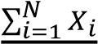
̅ 𝑛^{𝑖} 𝑋_{𝑖} 𝑝̂ = 𝑋 𝜇 𝑋
∑
=
1
𝑁𝑛 𝑛

𝑠 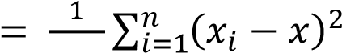̅ 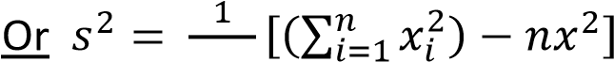̅ 𝑛 𝑛

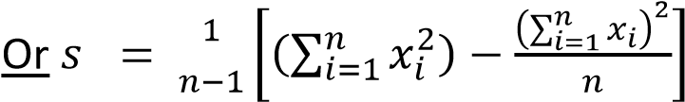

𝜎
𝑁 𝑁

𝑅𝑎𝑛𝑔𝑒 𝜎 𝑠
𝑠~ 𝐶𝑉 = 𝑐𝑣 =
4 µ 𝑥̅

Location of the p^{th} percentile:

𝐿𝑝= ^{𝑝} (𝑛+1)
100

IQR = Q₃ – Q₁

Expected value of a discrete random variable
𝐸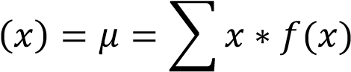

Variance of a discrete random variable
𝑉𝑎𝑟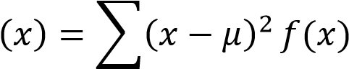

Z and t formulas:

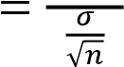
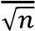
𝑥−𝜇 ̅ 𝜇 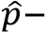𝑝𝑥̅𝜇 𝑍 = 𝑍 𝑍 𝑡 _{𝑠}
=
√
𝜎𝑝𝑞
𝑛
Confidence intervals

Mean:

𝑥
̅
±
𝑧
𝛼
/
2
𝜎
√
𝑛

𝑠
𝑥̅ 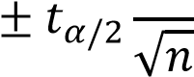

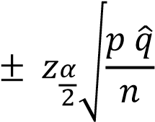
̂
𝑝̂
𝑧_{𝛼}²/2 𝑝 𝑞
𝑛 = 𝐵₂
Time Series Regression
𝑏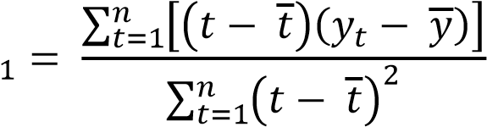

𝑏₀ = 𝑌 − 𝑏₁𝑡

𝑇_{𝑡} = 𝑏₀ + 𝑏₁𝑡
ANOVA:

𝑆𝑆𝑇𝑅
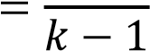
MSTR

𝑘 ₂
SSTR = ∑ 𝑛_{𝑗}(𝑥_{𝑗}̅ − 𝑥̿)
𝑗=1
𝑘
SSE = ∑(𝑛_{𝑗} − 1)𝑠_{𝑗}²
𝑗=1

Simple Linear Regression:

̂𝑦 = 𝑏₀ + 𝑏₁𝑥
∑(𝑥_{𝑖} − 𝑥̅)(𝑦_{𝑖} − 𝑦̅)
𝑏₁ = ∑(𝑥_{𝑖} − 𝑥̅)₂ SSE
MSE =
𝑛_{𝑇} − 𝑘
𝑘 𝑛𝑗
2 SST = ∑ ∑(𝑥_{𝑖𝑗} − 𝑥̿)
𝑗=1 𝑖=1

F = MSTR / MSE
𝑏₀ = 𝑦̅ − 𝑏₁𝑥̅
SST = SSR + SSE

SSE = ∑(𝑦_{𝑖} − 𝑦̂_{𝑖})² SST = ∑(𝑦_{𝑖} − 𝑦̅)²

SSR= ∑(𝑦̂_{𝑖} − 𝑦̅)²

Coefficient of determination

R²= SSR/SST

Correlation coefficient
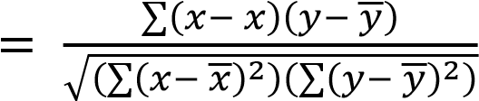
𝑌
=

∑
𝑋𝑌
−

∑
𝑋

∑
𝑁
√
(
∑
𝑋
2
−

(
∑
𝑋
)
2
𝑁
)
(
∑
𝑌
2
−

(
∑
𝑌
)
2
𝑁
)
̅
𝑟 or 𝑟

R2 = (𝑟𝑥𝑦 )2

𝑟_{𝑥𝑦} = (sign of 𝑏₁) Coefficient of Determination
√

Testing for Significance

s = MSE = SSE/(n 2) s = 
=
√
SSE
𝑛
−
2
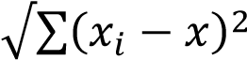
^{𝑠𝑏}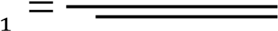 𝑠 ̅ ^{𝑡 =} 𝑠𝑏_{𝑏1}1 F = MSTR / MSE

MSR = SSR/k-1 MSE = SSE/n-k

Confidence Interval for β₁

𝑏1 ± 𝑡𝛼/2𝑠𝑏₁

Multiple Regression:
y =  + x + x +. . . + x + 
0 1 1 2 2 p p

𝑦̂ = b + b x + b x + . . . + b x
0 1 1 2 2 p p
² ²) 𝑛 
𝑅_{𝑎} = 1 − (1 − 𝑅
𝑛 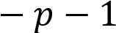
R² = SSR/SST
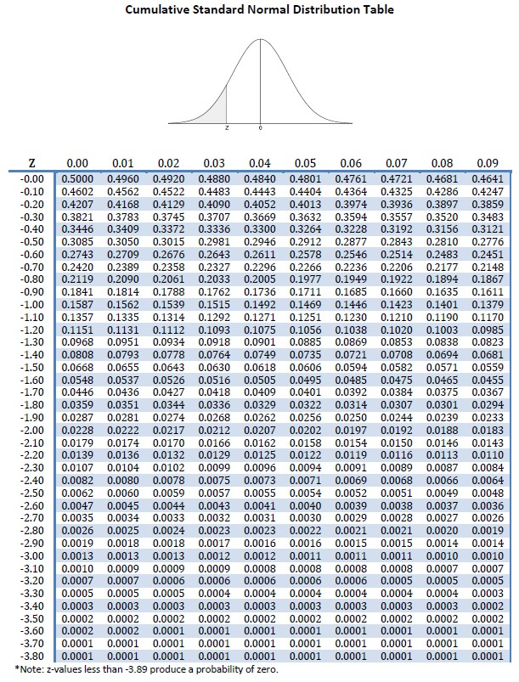
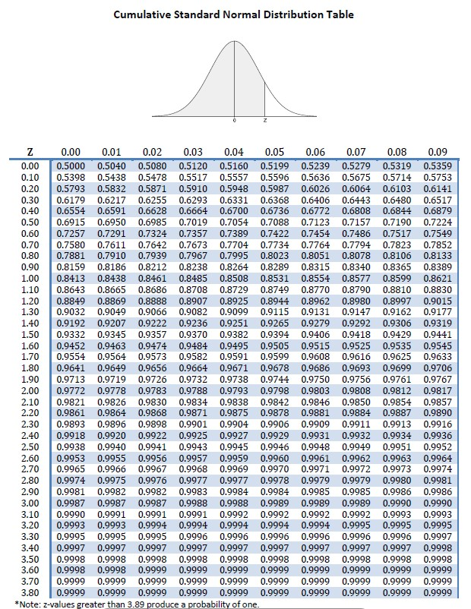
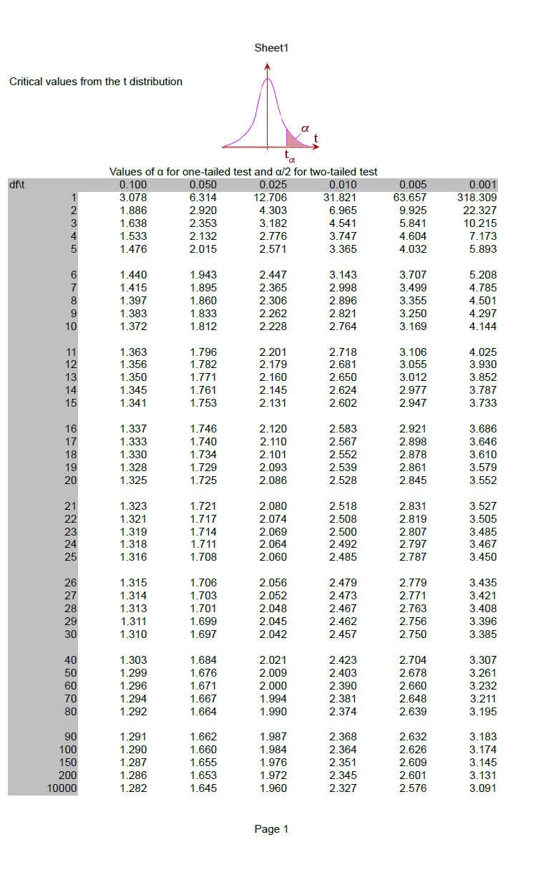

\F distribution
