1:

evaluate an improper integral.
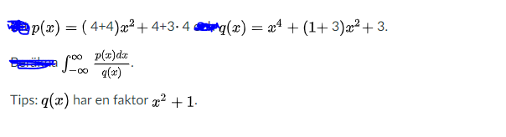

2:

We have function f(x) and as you see f(0)=b, f(1)=0 and f prime =sin X³
The definite integral below should be integrated
