DSE2051 Information Systems Management

Assignment: Access Database

The community centre in your neighborhood runs a comic library system, in which all registered users can borrow up to four comic books for up to two weeks at any one time. Recently the centre is computerizing the system. A preliminary design of the library database system is as follows.
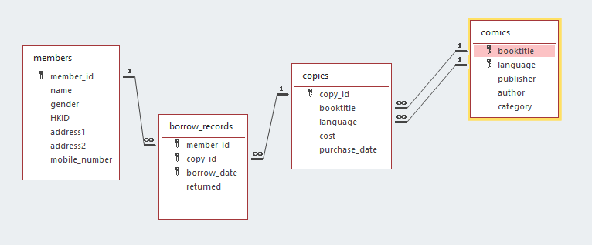
The table members stores the data of each registered member of the library system.
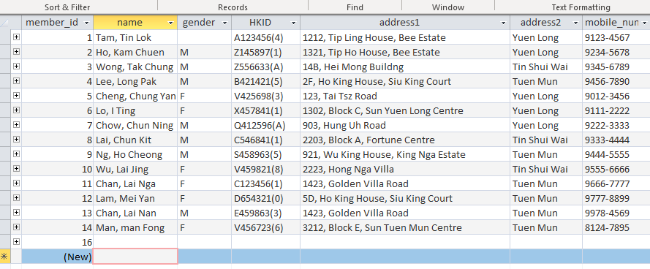
The table comics stores the data concerning details of each type of comic book in the library. They include book title, language, publisher, author, and category. Note that there may be multiple copies of the same comic title, determined jointly by booktitle + language.
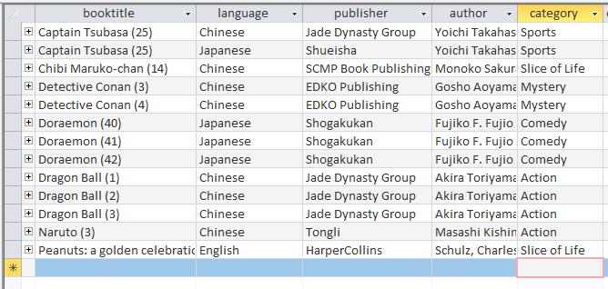
The table copies stores the cost and purchase date for each copy of comic purchased.
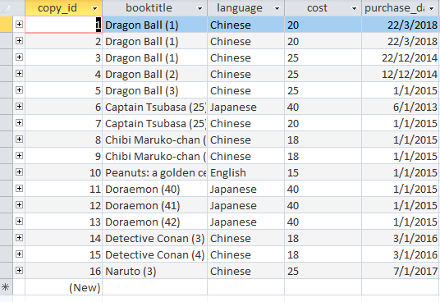
The table borrow_records stores the data concerning the borrow records of the copies, including the borrow date, expected return date (which is always two weeks after the borrow date), and whether the book has been returned or not (the default value should be FALSE).
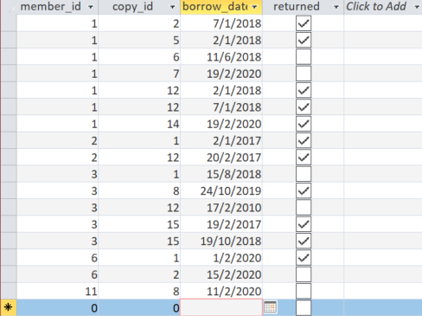

Let’s assume that the above database design has already been implemented using MS Access. Users are now ready to obtain useful information from the database. Please respond to the following data requests by creating corresponding SQL commands for information retrieval.
- Total cost of all the copies in the library
- The average costs of all the comic copies from individual publishers
- The borrowing count of the comic titles (a unique [booktitle, language] as a single comic title) within some two borrowing dates being specified dynamically, arranged in descending order of popularity
- The number of distinct comic titles in different categories
- The total number of copies held for each comic title, sorted by ascending order of comic title
- The number of members in different districts (e.g. Tin Shui Wai, Yuen Long and Tuen Mun)
- A list of copies purchased before a specific date inputted dynamically. You should include the copy_id, booktitle, language and publisher.
- The list of copies currently being borrowed by a member whose ID is being inputted dynamically. You should include the copy_id, booktitle, language and expected due date.
- A list of overdue copies. You should include the copy_id, booktitle, language and expected due date.
- A list of members who have overdue books. List these member IDs, full names and mobile numbers.
Label the queries as q-01, q-02 …, q-10.

Submission
Name your assignment file xxxxxxxxxx (your 10-digit student ID) and upload it to Blackboard’s assignment collection drop box by March 27 before midnight. Late submission will not be accepted.

